ECA6102 – COMPUTER NETWORKS AND CYBERSECURITY

NAME: Pavitra I
REG.NO: 192512035
EXP – 03
Configuration and Analysis of DNS and DHCP Services for Automated Network Address and Name Management using Cisco Packet Tracer
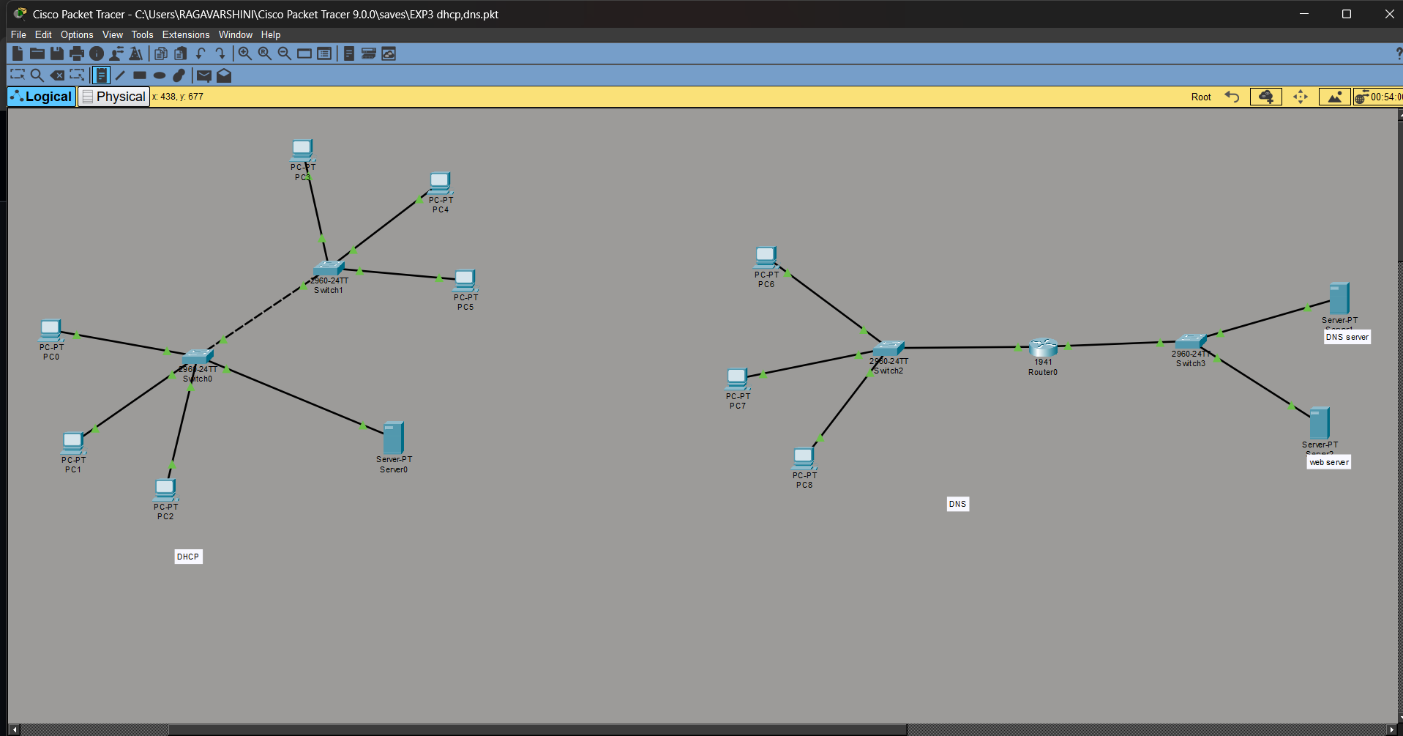

OUTPUT:
a) DHCP Protocol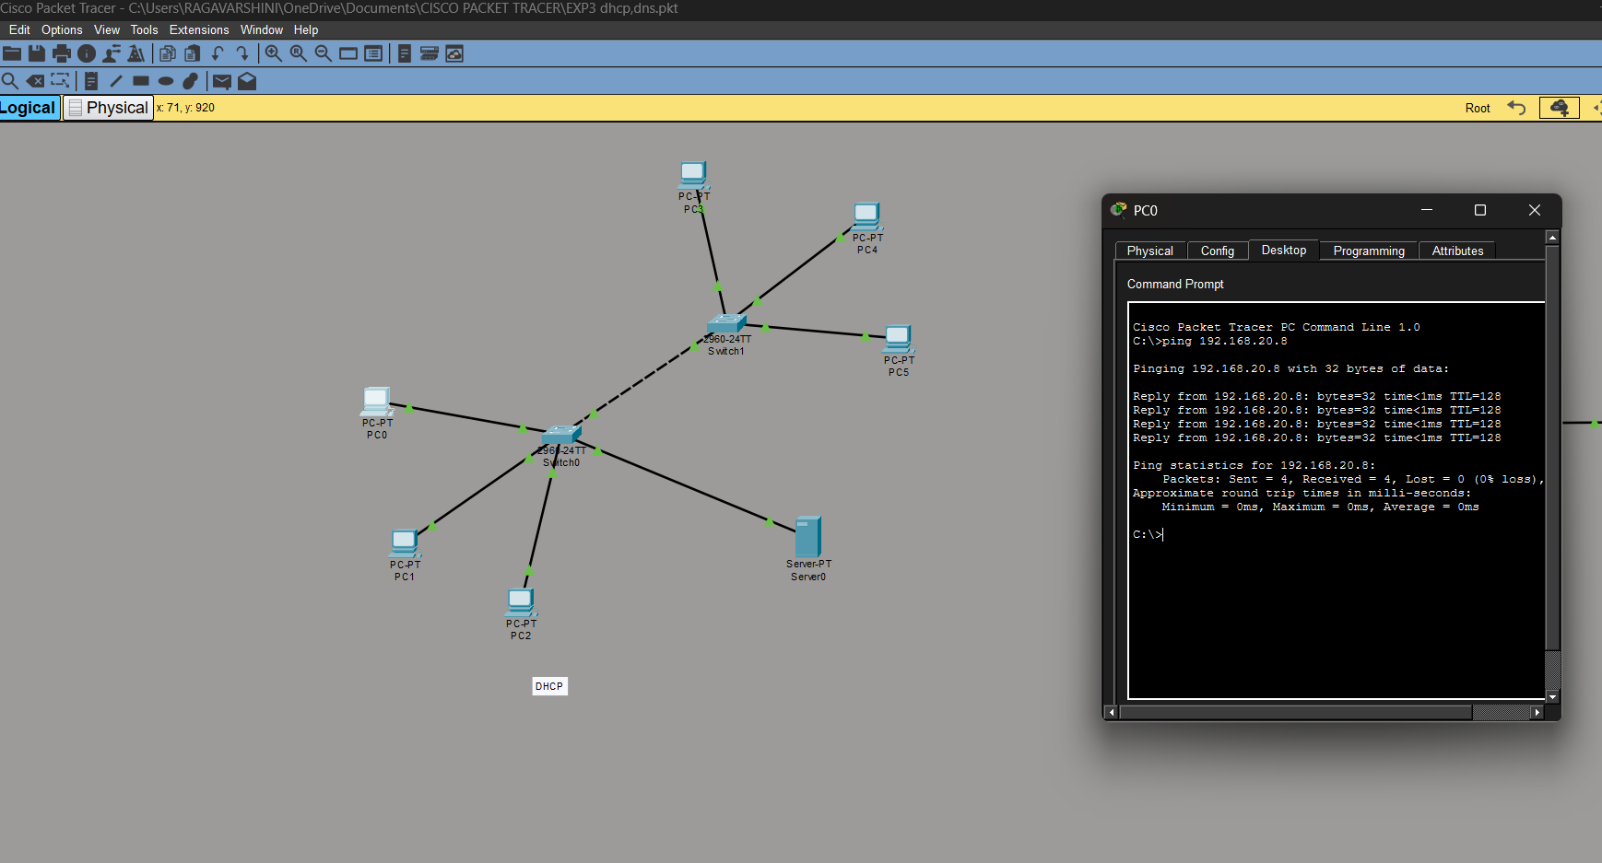
b) DNS protocol
